CUSTOMER SUPPORT TICKET PRIORITY PREDICTION
AND AUTOMATED ASSIGNMENT SYSTEM USING AGENTFORCE

User Story:
The Customer Support Ticket Priority Prediction and Automated Assignment System
combines Salesforce and Agentforce to read the description of each customer support
ticket, rate its urgency as High, Medium, or Low, and start the right backend automation.
It relies on the Support Ticket Intelligence custom object, an Auto-Launched Flow, and
an Agentforce subagent called Support Ticket Priority Analysis. Tickets rated High
generate an urgent handling task and go to a senior support agent, which cuts manual
work and shortens response times. The goal is to remove repetitive triage work and give
customers faster answers.

1. INTRODUCTION

1.1 Project Overview :
Support teams handle a high volume of tickets every day, and sorting and routing them
by hand is slow. This project delivers a Salesforce-based solution that reviews ticket
details, judges how urgent each case is, selects the suitable support level, and launches
automation for critical issues.

1.2 Purpose :

- Rank incoming support tickets as High, Medium, or Low priority automatically.
- Fetch the most recent support ticket linked to a customer Account.
- Cut down the manual work of prioritizing and assigning tickets.
- Generate an urgent handling task whenever a ticket is High priority.
- Let Agentforce review ticket details and start the backend automation.
- Speed up ticket response and resolution.

2. IDEATION PHASE
2.1 Problem Statement (Customer Problem Statement Template)

PS | I am  (Customer  ) | I’m trying to | But | Because | Which makes me  feel
PS-1 | Support  Agent | handle the most  urgent tickets  first | new tickets are  rarely ranked by  urgency  automatically | ranking is  done by  hand | annoyed
PS-2 | Customer | see urgent  problems  solved  promptly | serious problems  can sit behind  less important  tickets | support  teams are  handling  heavy ticket  loads | worried
PS-3 | Support  Manager | route tickets to  the correct  support tier | routing often  needs a manual  decision | urgency is  not judged  the same  way every  time | swamped
PS-4 | Support  Agent | spot urgent  problems in the  description text | key words are  easy to overlook | descriptions  carry a wide  range of  urgency  cues | unsure
PS-5 | Support  Manager | limit the risk of  missing SLAs | aging open  tickets can go  unseen | SLA risk  requires  extra review | worried

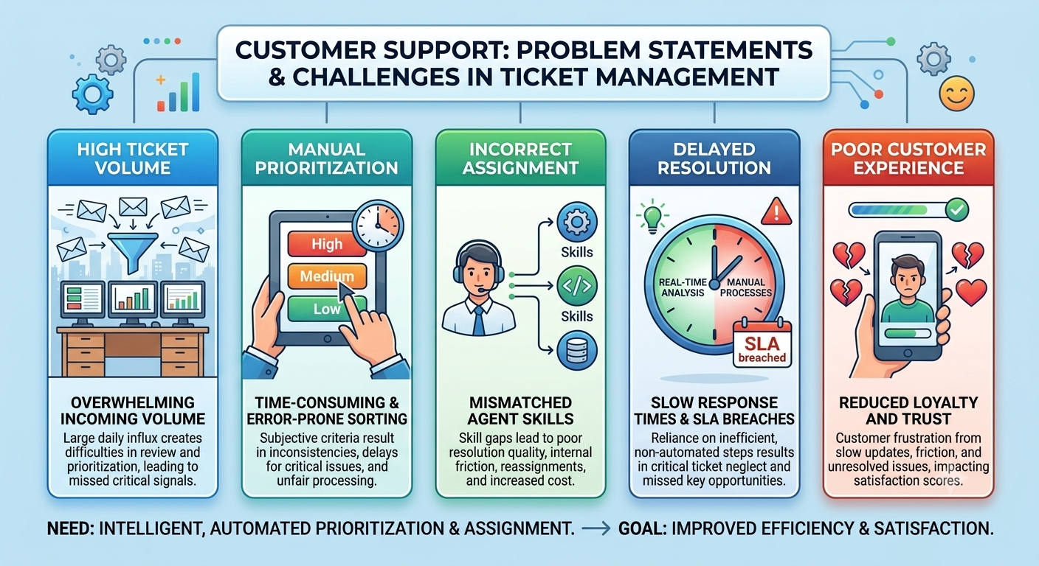

2.2 Empathy Map Canvas

User Persona: Support Agent
Think & Feel: Needs critical issues flagged right away so that urgent customer cases are seen first.
Hear: Takes in customer issue reports and support requests.
See: Ticket status, issue type, description, priority, assignment, and SLA risk
indicators.
Say & Do:Goes through tickets, works assigned cases, and concentrates on urgent
issues.
Pain: Prioritizing by hand, overlooked urgency cues, and slow handling of critical
tickets.
Gain: Priority set automatically, clearer assignment, urgent tasks created, and less
manual work.
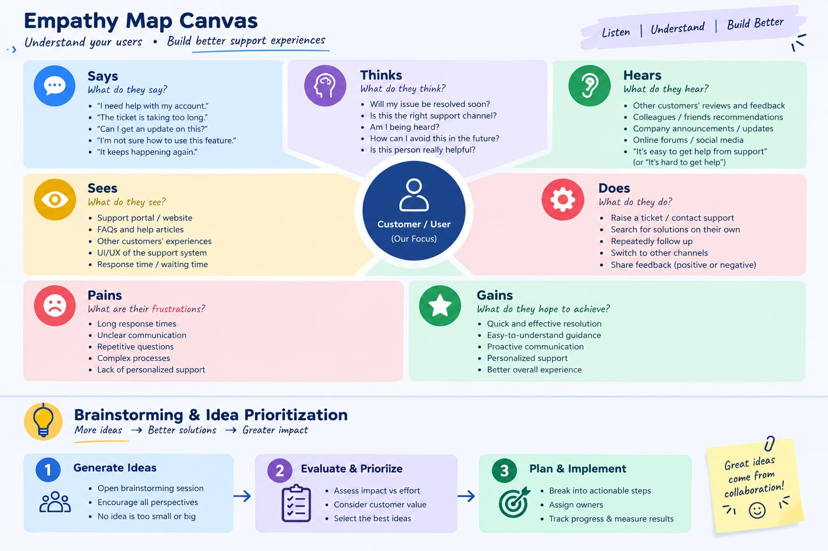

2.3 Brainstorming & Idea Prioritization

Ideas Considered

Handwritten ticket registers

Tracking tickets in spreadsheets

A separate standalone support portal

Salesforce CRM with Agentforce

Final Selection
Salesforce CRM selected due to:
- Workflow automation using Salesforce Flow
- AI-assisted ticket review with Agentforce
- Automatic classification of ticket priority
- Automatic creation of urgent tasks
- Less manual effort for the support team
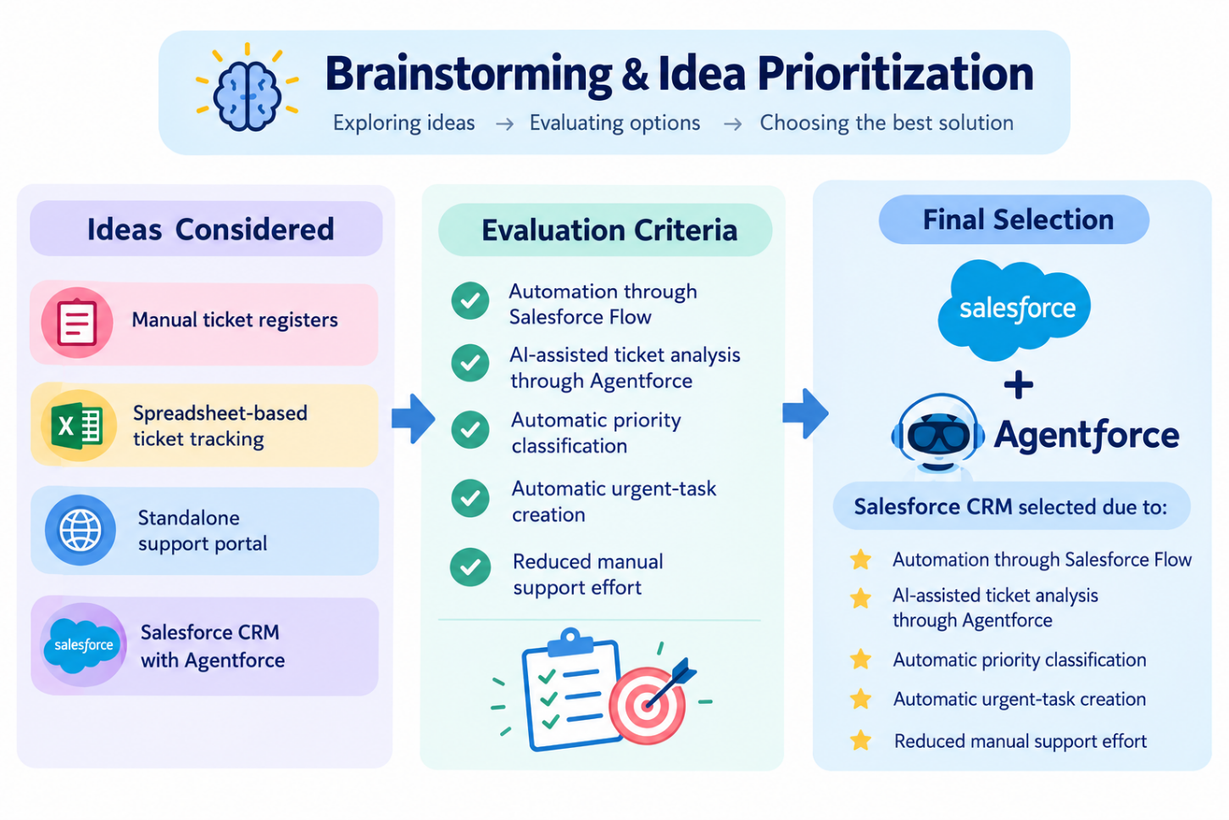

3.REQUIREMENT ANALYSIS PHASE

3.1 Customer Journey Map
Stages:
Ticket Creation → Account Identification → Ticket Retrieval → Description
Analysis → Priority Classification → Agent Assignment → Urgent Task Creation → Support Handling → Resolution

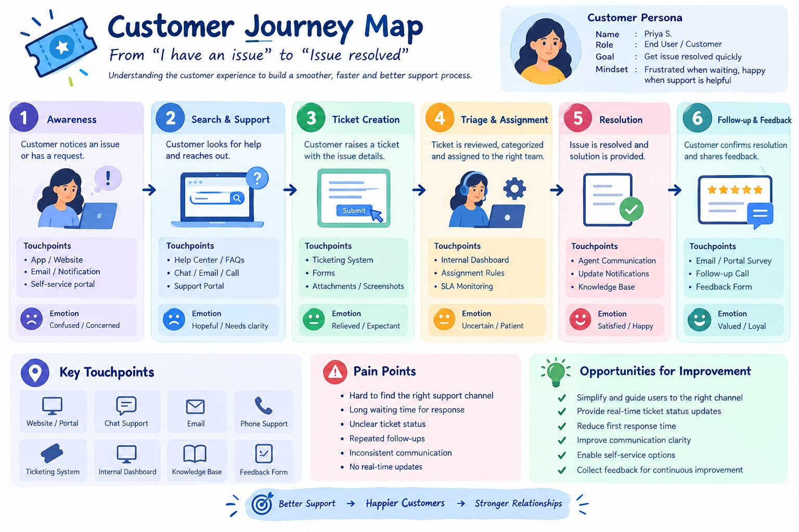

3.2 Solution Requirements

Functional Requirements
FR No | Requirement
FR-1 | Creating and managing support tickets
FR-2 | Linking tickets to Accounts and Contacts
FR-3 | Reading and analyzing ticket descriptions
FR-4 | Automatic assignment of priority levels
FR-5 | Task creation for High-priority tickets
FR-6 | Assignment to the right support agent
FR-7 | Checking tickets for SLA breach risk
FR-8 | Conversational analysis through Agentforce

Non-Functional Requirements

NFR | Description
Usability | Agentforce conversations are clear and priority  messages are easy to understand
Reliability | Priority results stay consistent because they follow  the configured conditions
Performance | Fast lookup and analysis of the most recent support  ticket
Security | Salesforce access to customer and ticket data is kept  under control
Maintainability | Flow and Agentforce settings are easy to edit
Scalability | Salesforce automation handles growing support  ticket volumes

3.3 Data Flow Diagram
Flow:
Customer / Support Request → Account → Latest Support Ticket → Ticket Description
→ Analyze Description → Priority Level → High/Medium/Low Decision → Agent Assignment → High-Priority Task (if applicable) → Final Response
Agentforce: User provides Account Name → Agentforce Support Ticket Priority Analysis → Auto-Launched Flow → Ticket Analysis → Priority and Assignment Output → Response to User.
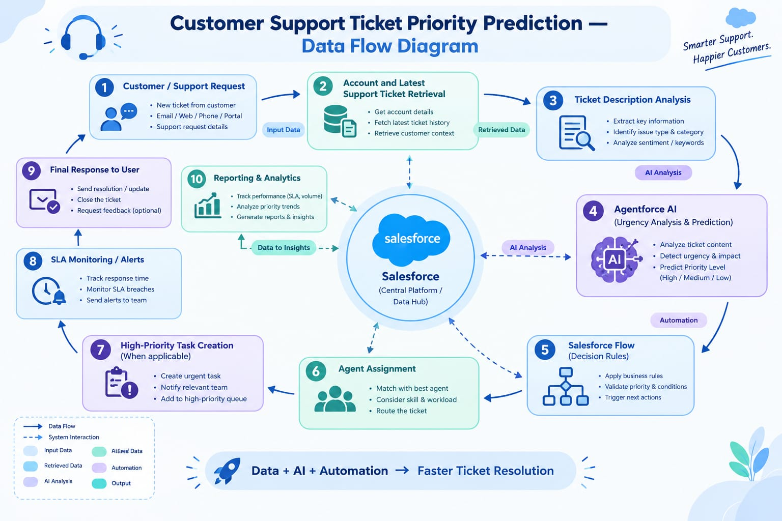

3.4 Technology Stack

Layer | Technology
Platform | Salesforce
Database | Support_Ticket_Intelligence__c with Account, Contact, User and Task records
Logic | Auto-Launched Flow
AI | Agentforce
Agent Configuration | Support Ticket Priority Analysis subagent
Automation | Flow Decision, Assignment and Create Records
Output | Response delivered in the Agentforce conversation

4. PROJECT DESIGN PHASE

4.1 Problem–Solution Fit

Problem | Solution | Benefit
Tickets are ranked by  hand | Flow reads the description  and sets the priority | Quicker spotting of urgent cases
Urgent issues can be  overlooked | Keyword-based  high-priority decision | Critical cases receive  prompt attention
Tasks created manually | Flow creates a Task for High priority tickets | Less manual effort
Support assignment done  by hand | Flow sets the assigned  support level | More uniform handling
SLA risk may go unnoticed | Optional SLA risk check | Improved risk visibility
Need for a conversational  interface | Agentforce subagent | AI-supported conversations

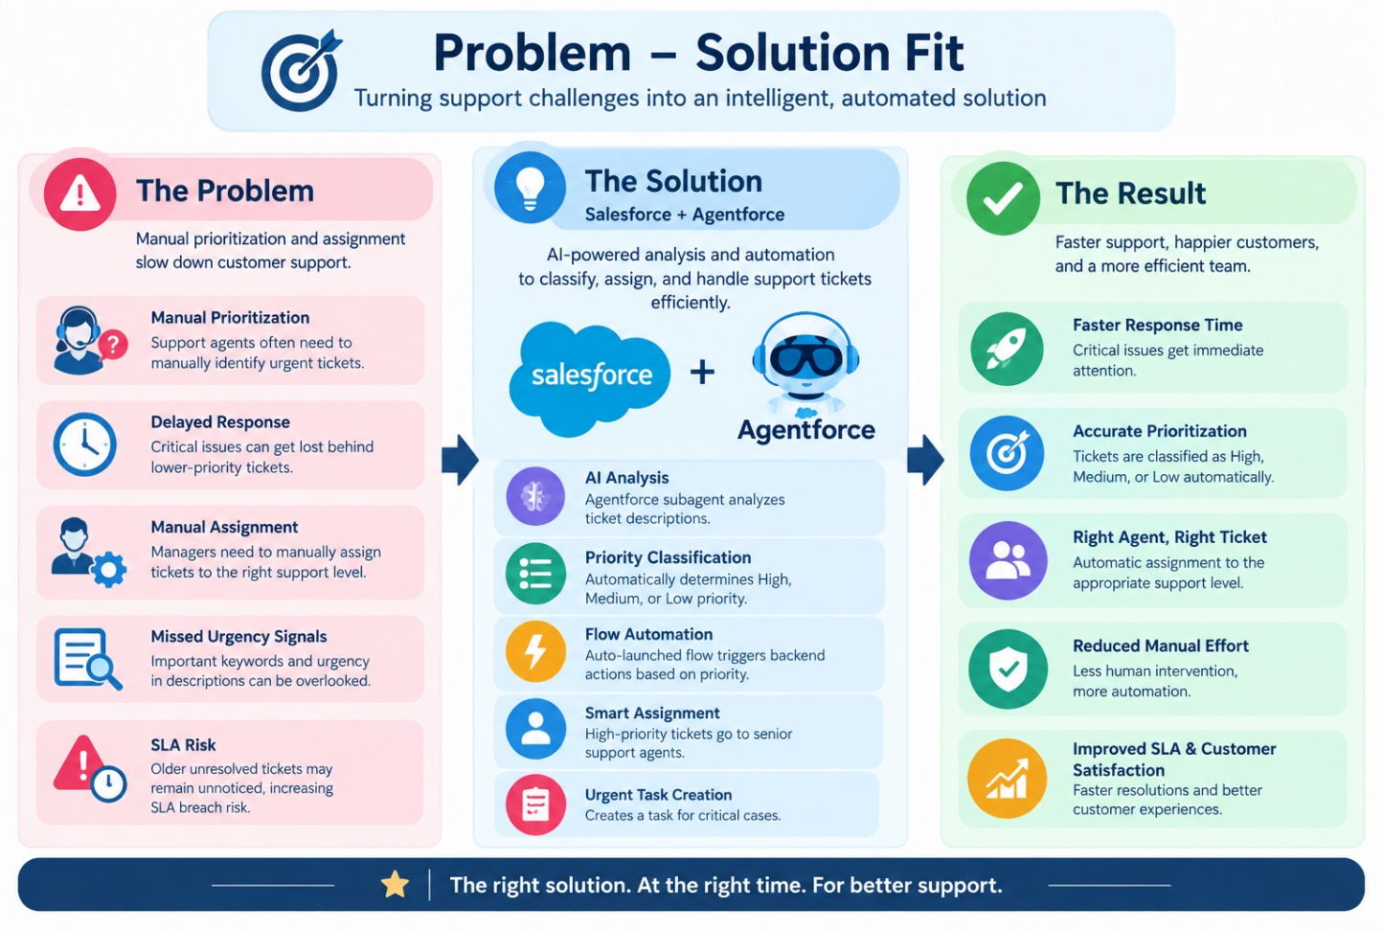

4.2 Proposed Solution

Functional Requirements

Parameter | Description
Problem | Slow, inconsistent manual prioritization and  assignment that delay critical support issues
Solution | A Salesforce solution for Customer Support Ticket  Priority Prediction and Automated Assignment
Innovation | Agentforce AI combined with an Auto-Launched  Flow to read ticket descriptions, classify their priority, choose the support level, and trigger  urgent-task automation
Impact | Critical tickets are spotted sooner, manual work  drops, responses are quicker, and support teams are  more productive
Business Model | Support operations that involve customers, support  agents, support managers, and AI-assisted ticket  handling
Scalability | Handles growing ticket volumes through Salesforce  automation, and leaves room for additional  assignment rules, deeper SLA monitoring, and more  priority indicators

4.3 Solution Architecture
Components:
Users / Support Team → Agentforce → Support Ticket Priority Analysis →
Auto-Launched Flow → Account & Ticket Data → Description Analysis → Priority Decision → Task / Assignment → Final 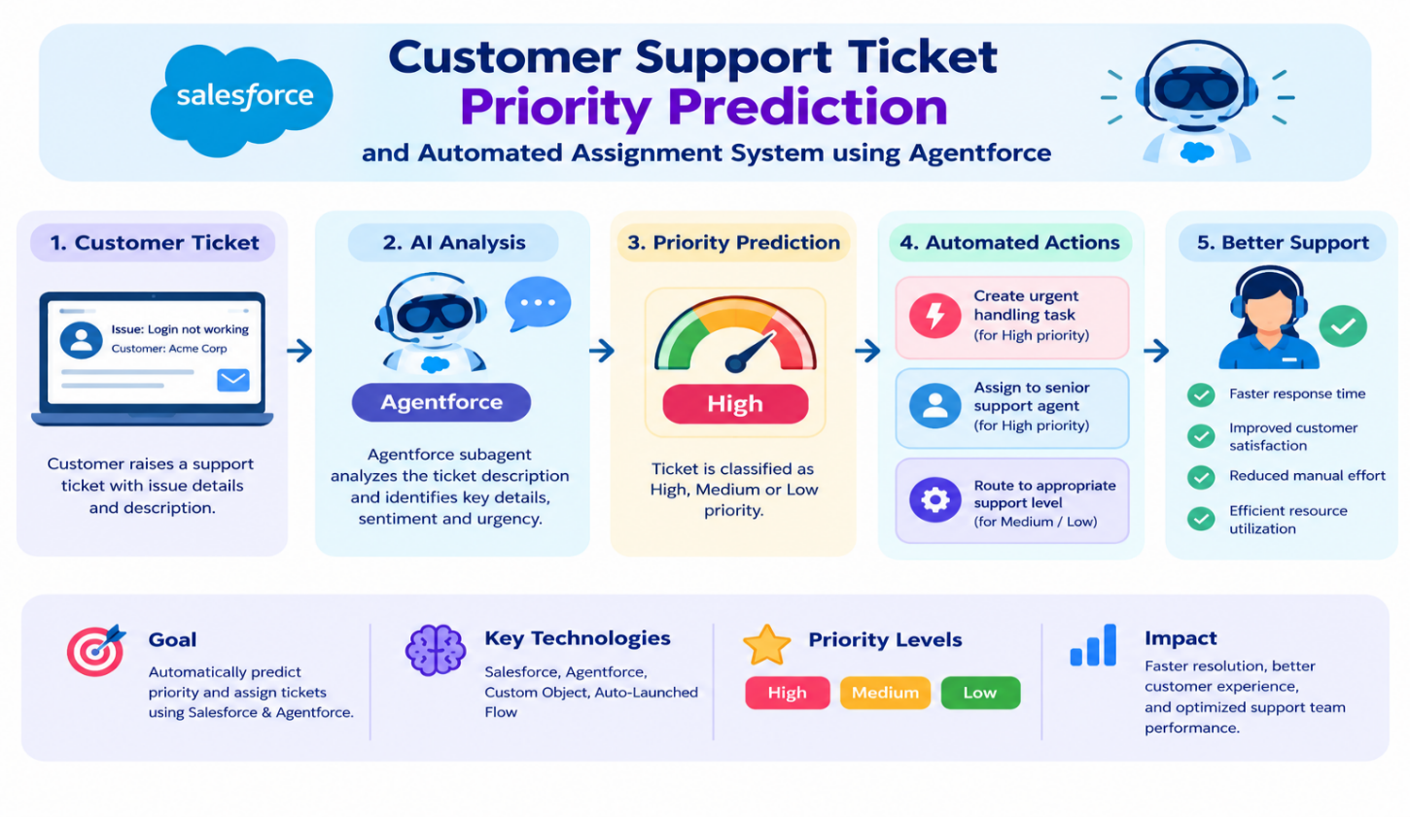

5. PROJECT PLANNING & SCHEDULING
5.1 Project Planning
- Agile delivery approach
- Epics → Stories → Story Points
- Work organized into sprints
- Estimates guided by velocity calculation
Product Backlog, Sprint Schedule, and Estimation (4 Marks)
Sprint | Functional  Requirement  (Epic) | User  Story  Number | User Story / Task | Story Points | Priority | Team  Member  s
Sprint-1 | Developer Setup | USN-1 | As a system administrator, I want to  set up the Salesforce environment  for Support Ticket Intelligence so  that the support automation solution | 3 | High | Member1
Use the below template to create product backlog and sprint schedule
Sprint | Functional  Requirement  (Epic) | User  Story  Number | User Story / Task | Story Points | Priority | Team  Member  s
 |  |  | can be built.
Sprint-2 | Data Modeling | USN-2 | As an admin, I want to build the  Support Ticket Intelligence object  with the needed fields and  relationships so that customer ticket  data is stored in an organized way. | 5 | High | Member2
Sprint-2 | Data Modeling | USN-3 | As a support user, I want support tickets to be associated with Accounts and Contacts so that the latest customer ticket can be identified for analysis. | 3 | High | Member3
Sprint-3 | Automation | USN-4 | As a support agent, I want an  Auto-Launched Flow that fetches  the latest ticket and examines its  description so that priority can be  decided automatically. | 5 | High | Member4
Sprint-3 | Automation | USN-5 | As a support agent, I want tickets  automatically labeled High,  Medium, or Low according to set  urgency conditions so that critical  issues are handled first. | 5 | High | Member4
Sprint-4 | Agentforce & Automation | USN-6 | As an AI Agent (Agentforce), I want  to review ticket details and run the  backend Flow so that manual  prioritization is minimized. | 8 | High | Member1
Sprint-4 | Task &  Assignment | USN-7 | As a support manager, I want  High-priority tickets to automatically  produce an urgent handling task  and be given to the proper support  level so that critical tickets are  resolved quickly. | 5 | High | Member2
Sprint-5 | SLA  Management | USN-8 | As a support manager, I want the  system to check older unresolved  tickets for SLA breach risk so that  potential SLA problems are  identified. | 5 | Medium | Member3
Sprint-6 | Agentforce &  Conversational  Support | USN-9 | As a support user, I want to give  Agentforce an Account Name and  get back the ticket ID, priority,  assigned agent, and action  message so that I can follow the  ticket handling result in a  conversation. | 5 | Medium | Member4
Sprint | Total Story Points | Duration | Sprint Start Date | Sprint End Date (Planned) | Story Points  Completed  (as on  Planned End  Date) | Sprint Release Date (Actual)
Sprint-1 | 20 | 6 Days | 24 Oct 2022 | 29 Oct 2022 | 20 | 29 Oct 2022
Sprint-2 | 20 | 6 Days | 31 Oct 2022 | 05 Nov 2022
Sprint-3 | 20 | 6 Days | 07 Nov 2022 | 12 Nov 2022
Sprint-4 | 20 | 6 Days | 14 Nov 2022 | 19 Nov 2022

Project Tracker, Velocity & Burndown Chart: (4 Marks)
6. Project Development Phase:

What you'll learn
- Data Modelling
- Fields and Relationships
- Lightning App Builder
- Record Triggered Flows
- Apex and Apex Triggers
- Batch Apex
- Scheduled Apex

Milestone 1: Salesforce Account
Activity 1: Creating Developer Account
Setting up a developer org in Salesforce.
- Go to https://developer.salesforce.com/signup
- Fill in the sign-up form with these details :
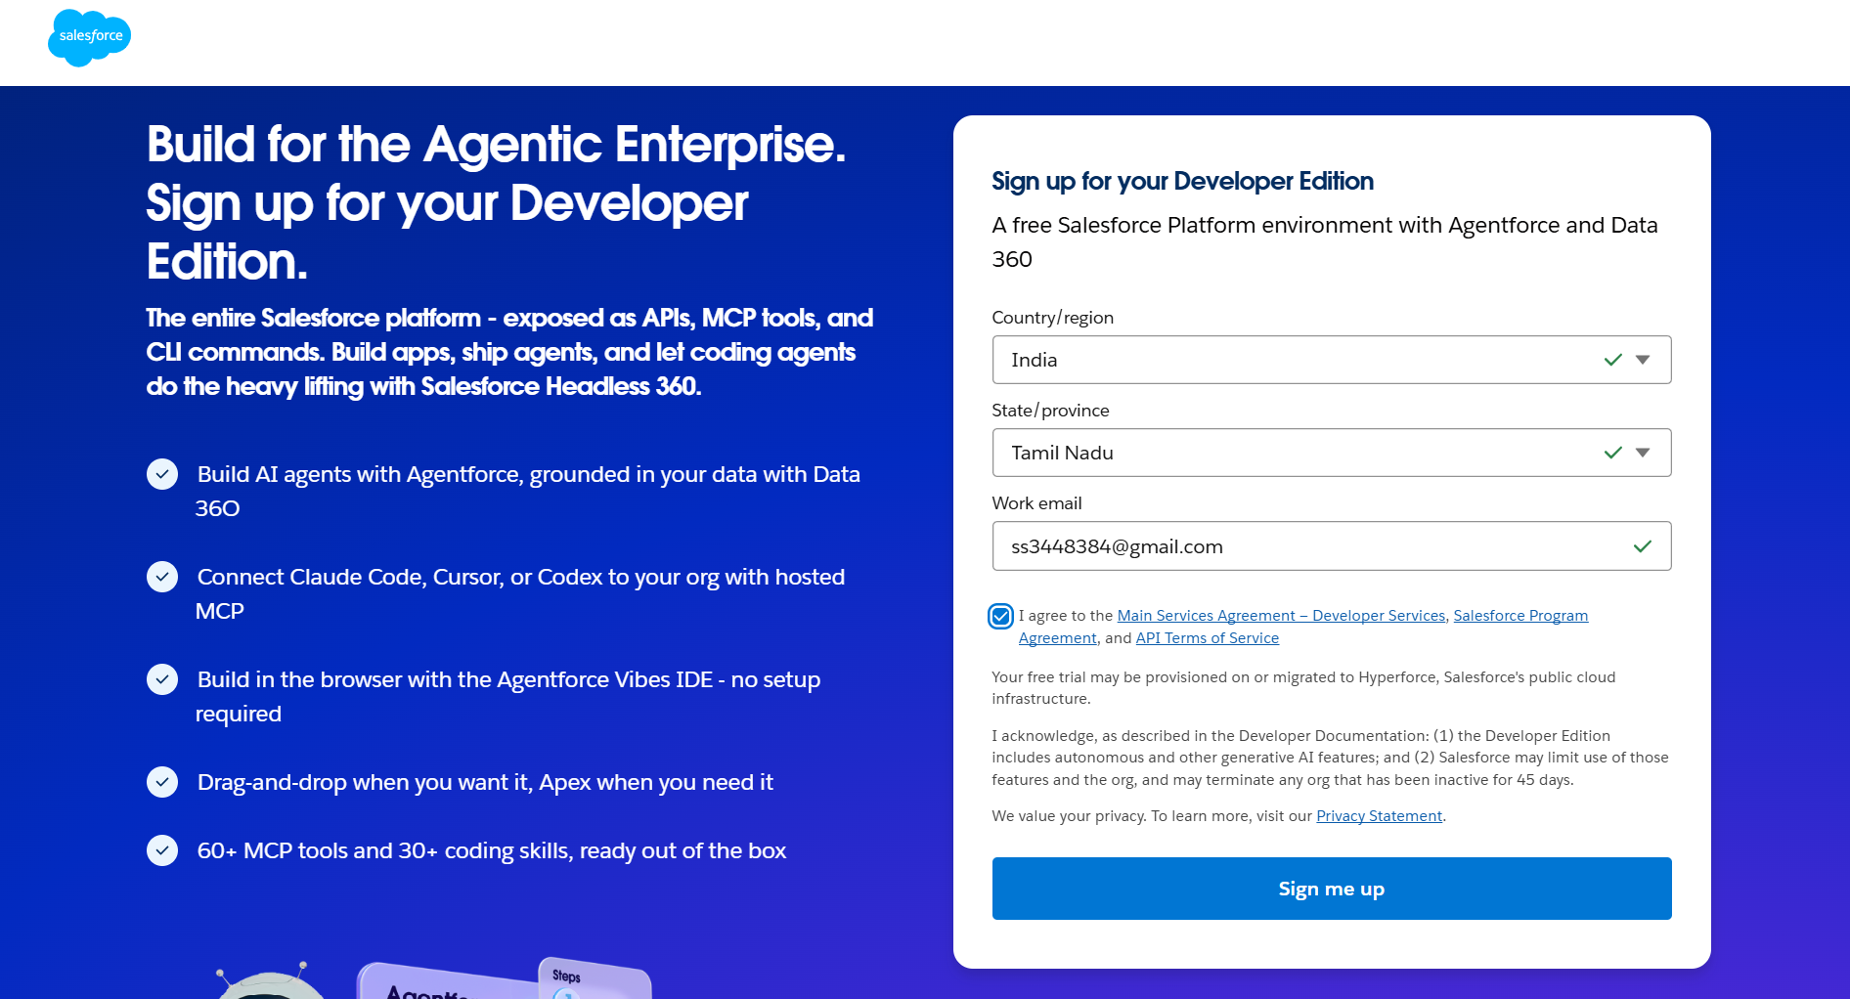
  - First name & Last name
  - Email : ss3448384@gmail.com
  - Role : Developer
  - Company : College Name
  - County : India
  - Postal Code : pin code
7) Username : should be combination of your name and company The email does not have to be real; any address in this format works :
username@organization.com Click on sign me up once the form is filled in.
Activity 2: Account Activation
1.Open the inbox of the email address used for sign-up and click on verify account toactivate it. The email can take 5-10 mins to arrive.

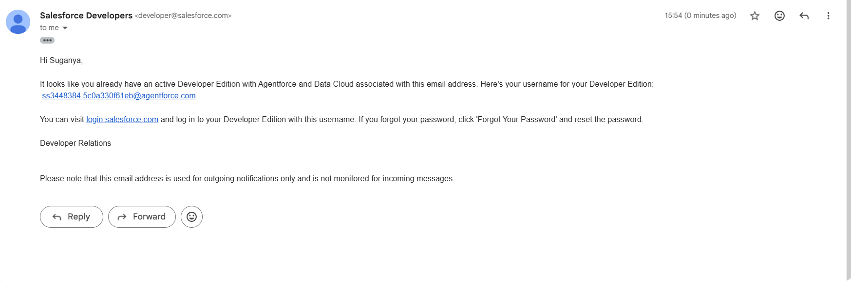

2.Click on Verify Account
3. Set a password, answer a security question, and click on change password
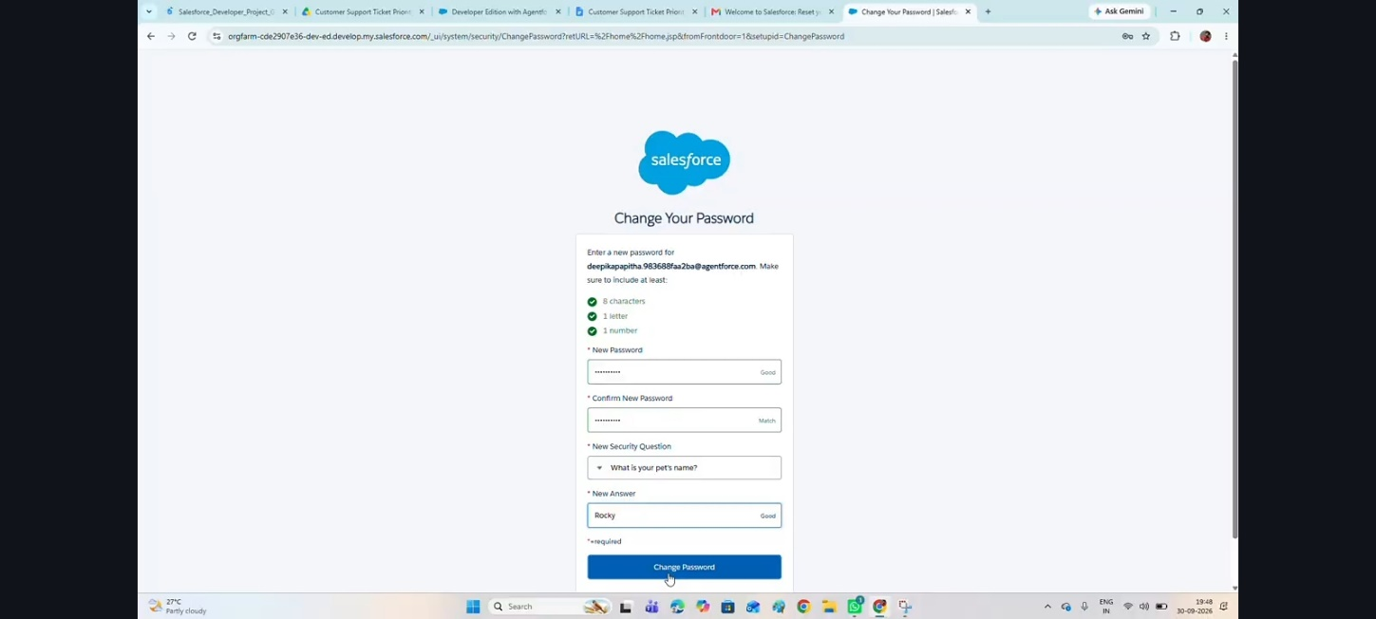
4. You will then be redirected to your Salesforce setup page.
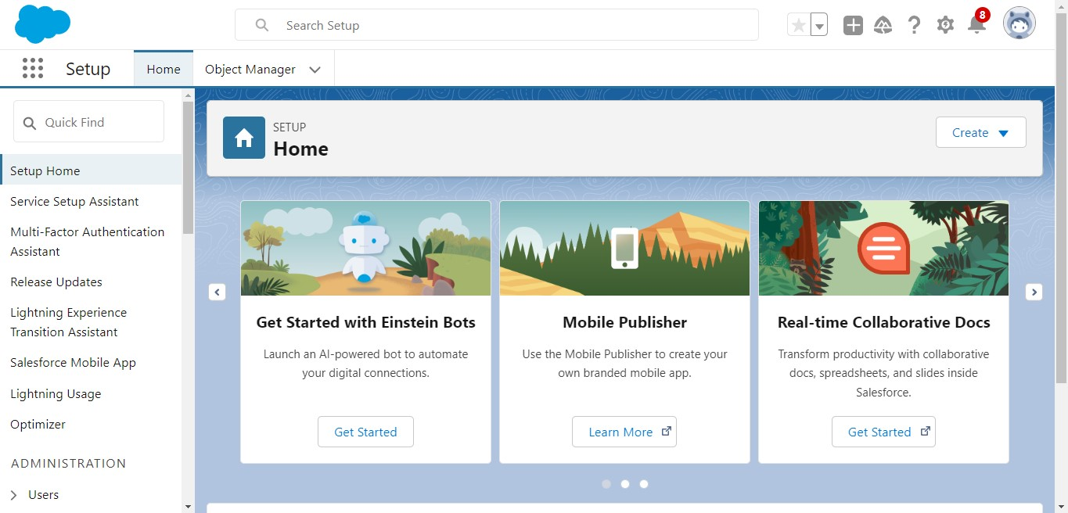

Milestone 2: Data Management-Objects

Custom Object
Object Name:
Support Ticket Intelligence
API Name:
Support_Ticket_Intelligence__c

Fields
Field Label | API Name | Data Type | Description
Ticket Number | Ticket_Number__c | Auto Number | TKT-{0000}
Customer | Customer__c | Lookup (Account) | Linked Account
Contact | Contact__c | Lookup (Contact) | Linked contact
Issue Type | Issue_Type__c | Picklist | Technical, Billing, General
Description | Description__c | Long Text Area | Details of the issue
Priority Level | Priority_Level__c | Picklist | Low, Medium, High
Status | Status__c | Picklist | New, In Progress,  Resolved
Created Date | Created_Date__c | Date | Date of the ticket
Assigned To | Assigned_To__c | Lookup (User) | Assigned support agent
SLA Breach Risk | SLA_Breach_Risk__  c | Checkbox | SLA risk indicator
Resolution Time  (hrs) | Resolution_Time__c | Number | Time to reslove
Auto-Launched Flow Logic (Modified for this Project)
1. Flow Type
Auto-Launched Flow (No Trigger or called from Agentforce)

2. Variables

Input Variable
Label | API Name | Type |  | Input
Account Name | varAccountName | Text | Yes

Output Variables
Label | API Name | Type |  | Output
Account Id | varAccountId | Text | Yes
Ticket Id | varTicketId | Text | Yes
Priority Level | varPriorityLe vel | Text | Yes
Assigned Agent | varAssignedTo | Text | Yes
Action  Message | varActionMess age | Text | Yes

3. Step-by-Step Flow Implementation

Step 1: Get Account
Element: Get Records
- Label: Get Account
- Object: Account
- Condition: Name Equals {!varAccountName}
- Sort: CreatedDate DESC
- Store: Only first record

Step 2: Assignment (Store Account Id)
Element: Assignment
- Label: Store Account Id Set:
- varAccountId = {!Get_Account.Id}

Step 3: Get Ticket Record
Element: Get Records
- Label: Get Ticket
- Object: Support_Ticket_Intelligence__c
- Condition: Customer__c Equals {!varAccountId}
- Sort: CreatedDate DESC
- Store: Only first record

Step 4: Assignment (Store Ticket Id)
Element: Assignment
- Label: Store Ticket Id Set:
- varTicketId = {!Get_Ticket.Id}

Step 5: Decision (Analyze Description)
Element: Decision
- Label: Analyze Description
Outcomes:
High Priority
- Description contains:
  - "urgent"
○ "not working"
○ "failure"
(Use multiple conditions with CONTAINS)
Medium Priority
- Description contains:
  - "issue"
○ "slow"
○ "delay" Default Outcome
- Low Priority

Step 6: Assignment (Set Priority Level)
High Path
- varPriorityLevel = "High"
Medium Path
- varPriorityLevel = "Medium"
Low Path
- varPriorityLevel = "Low"

Step 7: Decision (High Priority Check)
Element: Decision
- Label: Is High Priority
Condition:
- varPriorityLevel Equals "High"

Step 8: Create Task (Only High Priority)
Element: Create Records
- Object: Task
Set Fields:
- Subject = "Urgent Ticket Handling" ● WhatId = {!varTicketId}
- Priority = High
- Status = Not Started

Step 9: Assignment (Assign Agent Name)
Element: Assignment
- Label: Set Assigned Agent
Set:
- varAssignedTo = "Senior Support Agent"

Step 10: Optional SLA Check
Decision: SLA Risk
Condition example:
- If Created Date older than 2 days Then:
- (Optional internal flag or message)

Step 11: Final Output Message
Element: Assignment
- Label: Set Final Message Set varActionMessage:
- High:
"High priority ticket detected. Assigned to senior agent."
- Medium:
"Ticket marked as medium priority. Will be handled shortly."
- Low:
"Tickets are low priority and queued for processing."
Step 12 : Save Flow
Label Name : Support_Ticket_Intellegence
Active Flow

4. Final Flow Structure
Start
→ Get Account
→ Assignment (Account Id)
→ Get Ticket
→ Assignment (Ticket Id)
→ Decision (Analyze Description)
→ Assignment (Priority Level)
→ Decision (High Priority)
→ Create Task
→ Assignment (Assigned Agent)
→ Optional SLA Decision
→ Assignment (Final Message)
→ End

Flow OutPut :
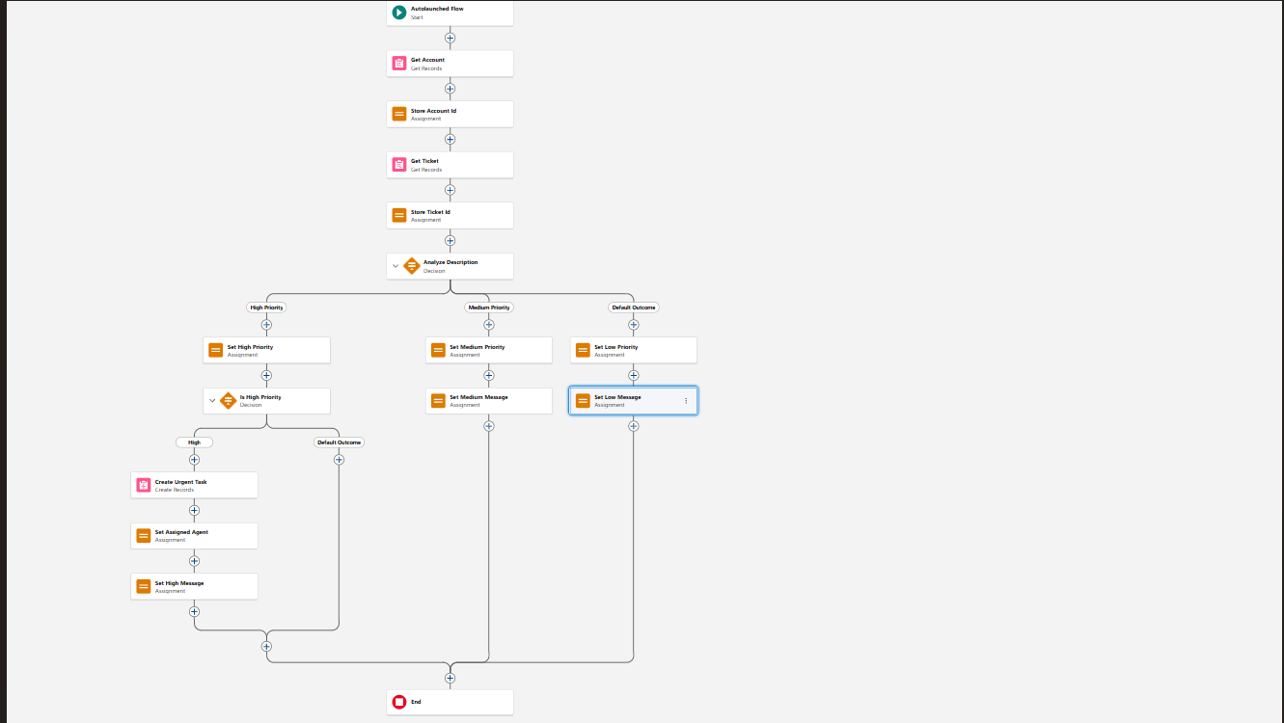
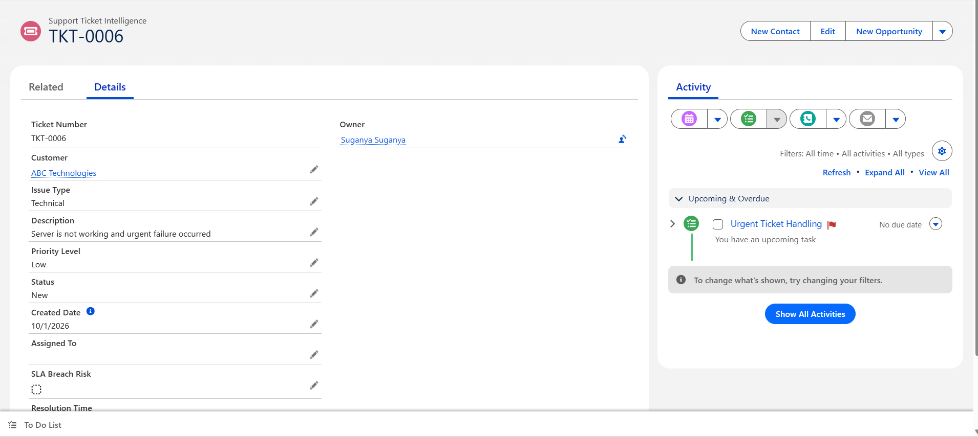

5. Final Outcome
- Takes Account Name as input
- Fetches latest support ticket
- Analyzes description using keywords
- Sets priority automatically
- Creates task for urgent cases
- Returns output to Agentforce

Agentforce Configuration
Steps :
- Click the gear icon and choose Salesforce Go 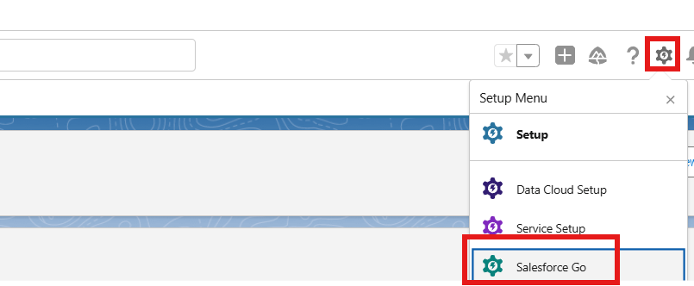
- Search for Default, pick Agentforce (Default), and enable it
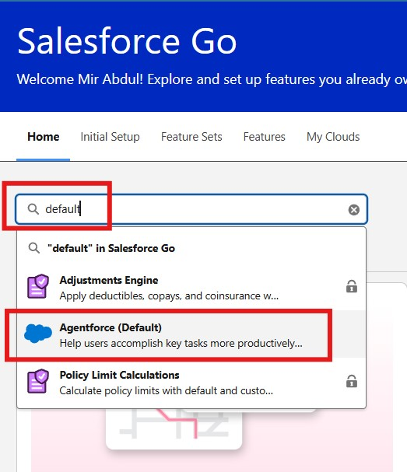
- Select Get Started ⇒ Turn On ⇒ Confirm
- Type Agents in the Quick Find box and enable the agent; the Default Agent will then appear

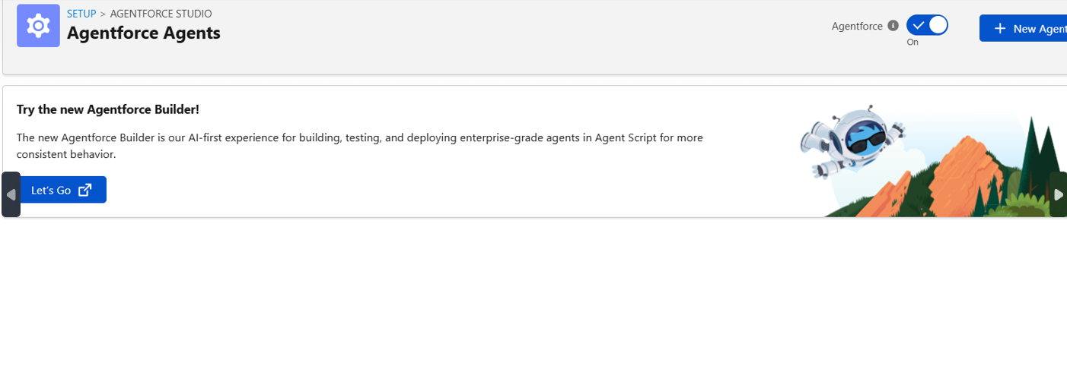
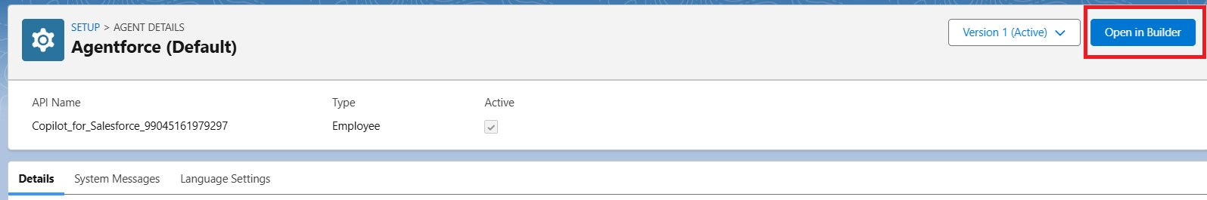
- Choose the Default Agent and click Open in Builder

- Click New to add a new SubAgent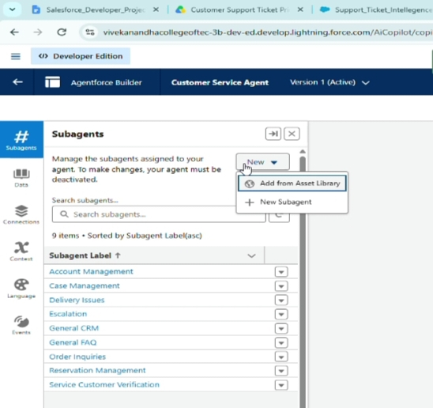
- Click Next
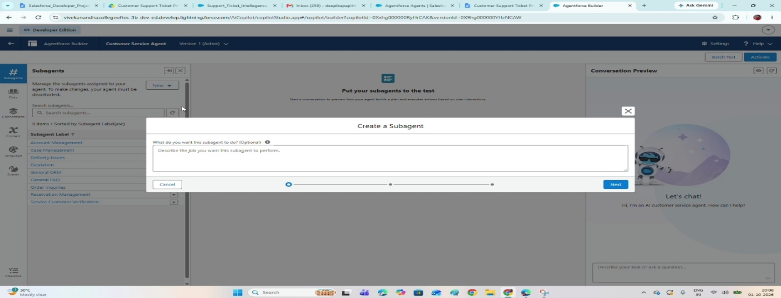
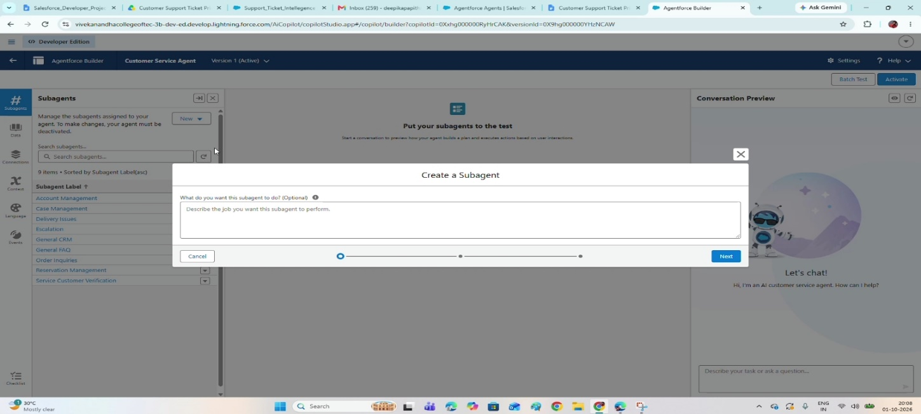
Agentforce Subagent Configuration
Name
Support Ticket Priority Analysis
API Name
Support_Ticket_Priority_Analysis

Classification Description

This topic reviews customer support tickets and sets priority from the issue description and

its urgency. It answers user requests about ticket status, issue severity, and support

prioritization.

Scope
Your only task is to analyze support ticket descriptions, decide the priority level (High,
Medium, Low), and start the backend automation for task assignment. Do not take on
unrelated requests such as billing, subscription management, or account updates.
Instructions
Carry out these steps whenever this topic is triggered:
1. Request the Account Name from the user if it has not been provided.
2. Fetch the most recent support ticket linked to that Account.
3. Read through the ticket description and analyze it.
4. Decide the priority using these keywords:
- High Priority: contains "urgent", "not working", "failure"
- Medium Priority: contains "issue", "slow", "delay"
- Low Priority: if none of the above
5. Record the matching priority level.
6. When the ticket is High Priority:
- Run the Auto-Launched Flow
- Make sure a task is created for immediate handling
7. Route the ticket to a suitable support level (for example, a senior agent for high priority).
8. Give the user a clear response message:
- High → Say that urgent handling has started
- Medium → Say that the issue will be handled soon
- Low → Say that the ticket is queued

9. Never edit records directly or send emails; perform every action through Flow. 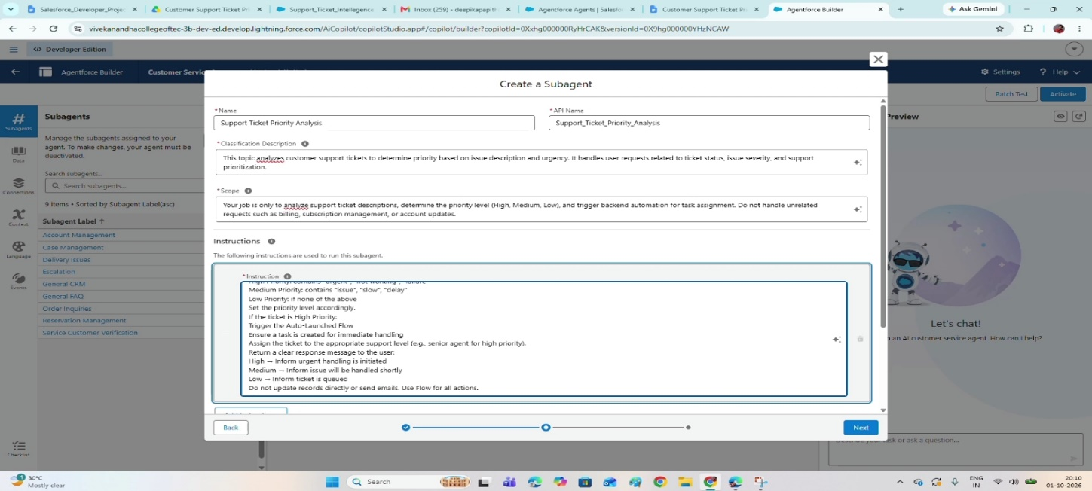

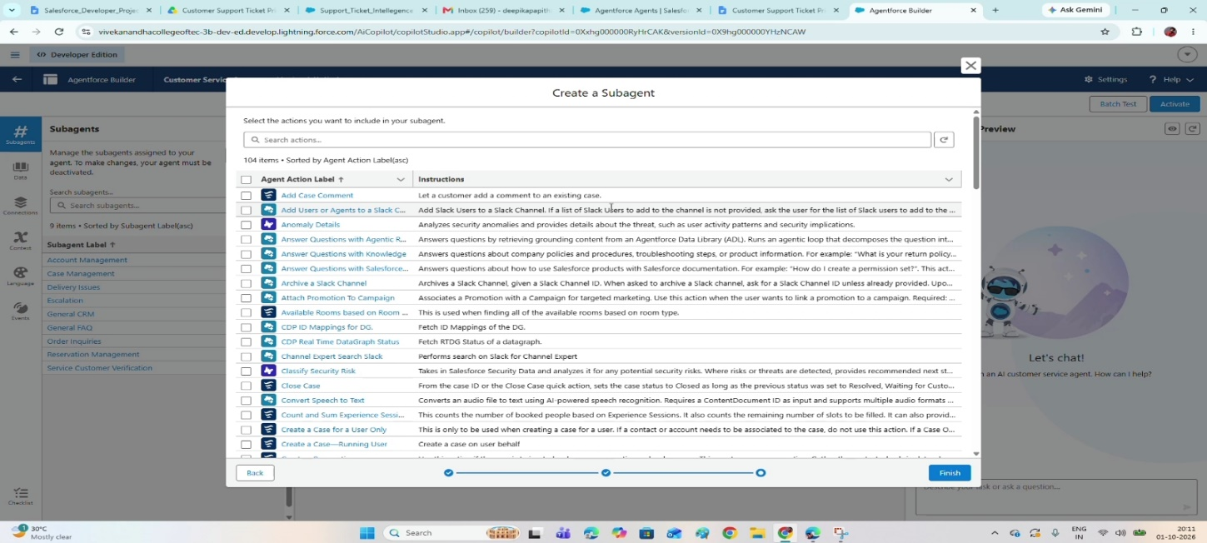
Select Topic

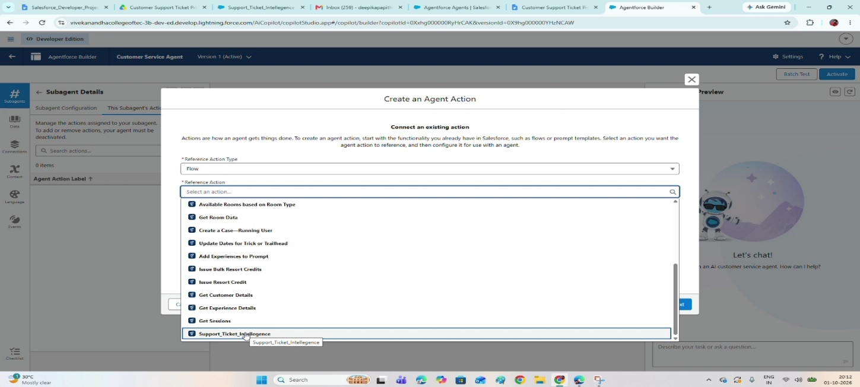

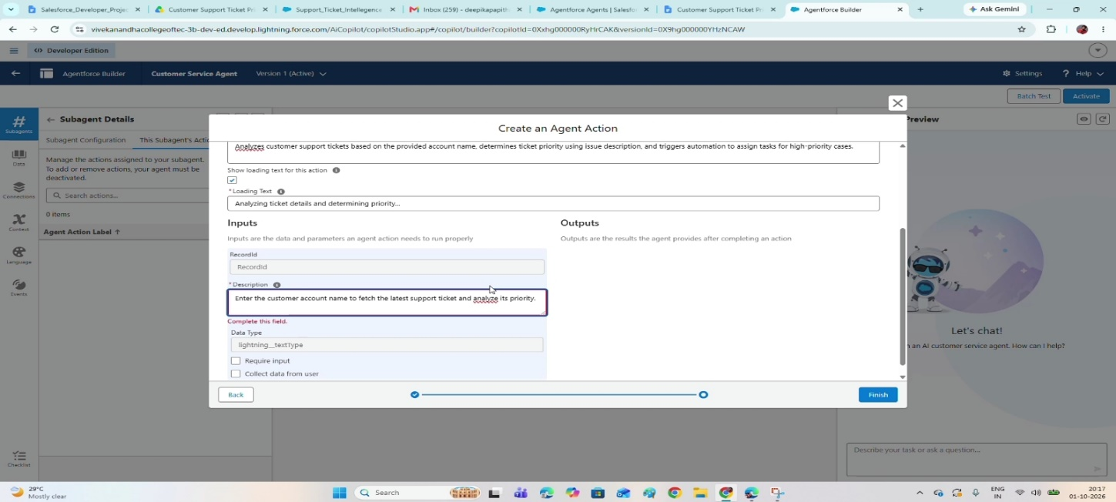

Agent Action Description
Reviews customer support tickets for the supplied account name, determines ticket priority
from the issue description, and triggers automation that creates tasks for high-priority cases.
Loading Text

Reviewing ticket details and deciding the priority...

Input

varAccountName
- Description
Provide the customer account name so the latest support ticket can be fetched and
its priority analyzed.
- Data Type
lightning__textType
- Require Input
Enabled
- Collect Data From User
Enabled

Outputs

varAccountId
- Description
Gives back the unique ID of the account used to find the support ticket.
- Data Type
lightning__textType
- Show in Conversation
Enabled
- Output Rendering
Text

varActionMessage
- Description
Shows the final message with the ticket priority and the actions taken.
- Data Type
lightning__textType
- Show in Conversation
Enabled
- Output Rendering
Text

varAssignedTo
- Description
Shows which support agent or team has been assigned to the ticket
- Data Type
lightning__textType
- Show in Conversation
Enabled
- Output Rendering
Text

varPriorityLevel
- Description
Holds the ticket priority level (High, Medium, Low) worked out from the issue description.
- Data Type
lightning__textType
- Show in Conversation
Enabled
- Output Rendering
Text

varTicketId
- Description
Gives back the unique ID of the support ticket the system analyzed.
- Data Type
lightning__textType
- Show in Conversation
Enabled
- Output Rendering
- Text
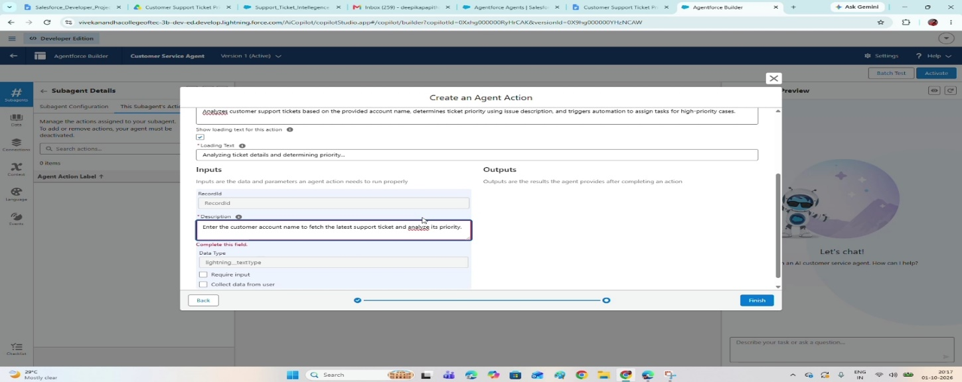
Final OutPut :
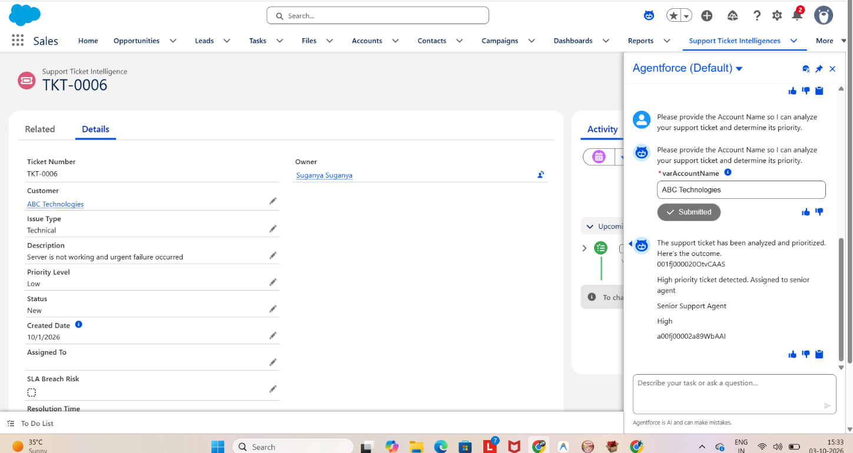

Note :To extend this scenario, add more variables to the flow and map them to the agent. This gives richer outputs and is a good way to keep learning. If you want to try other scenarios, feel free to reach out to me.

8.FUNCTIONAL & PERFORMANCE TESTING
During testing, screenshots were captured from Salesforce to validate ticket creation, priority classification, Flow execution, urgent task creation, agent assignment, and Agentforce responses. Each of these features was verified to ensure correct functionality and performance.
ADVANTAGES & DISADVANTAGES
Advantages:

Automatic Ticket Prioritization – Sorts support tickets into High, Medium, or Low

based on the ticket description.

Quicker Spotting of Critical Issues – Lets support agents concentrate on urgent

tickets first.

Less Manual Effort – Automates ticket analysis, priority setting, task creation, and

assignment.

Smart Ticket Handling – Agentforce reviews ticket details and starts the right

backend automation.

Automatic Urgent Tasks – High-priority tickets automatically get an Urgent Ticket

Handling task.

Better Support Assignment – Routes High-priority tickets to the suitable support

level, such as a senior support agent.

Conversational Support – Support users chat with Agentforce to analyze tickets

and get the result.

Faster Response – Automation helps reduce delays when handling critical

customer issues and urgent requests.

SLA Risk Awareness – Older unresolved tickets can be checked for possible SLA

breach risk.

Scalable Support Operations – Salesforce automation can cope with growing ticket

volumes.

Higher Team Productivity – Removes repetitive work so support teams can focuson resolving tickets.

Disadvantages
- Keyword-Based Priority Logic – The priority classification depends on configured
keywords such as urgent, not working, failure, issue, slow, and delay, so wording
matters.
- Limited Grasp of Context – The current setup may miss some urgency signals
because the logic is based only on configured conditions and not on the wider
context of each ticket description.
- Reliance on Accurate Ticket Data – Analysis only works when Account, Contact,
and ticket information is correct.
- Flow Maintenance Needed – Any change to ticket handling means updating the
Auto-Launched Flow and its logic.
- Agentforce Setup Dependency – Agentforce replies and actions rely on correctly
configured subagent instructions and Flow actions.
- Narrow Agentforce Scope – The subagent covers ticket analysis, priority
decisions, and backend automation only; unrelated requests such as billing or
subscriptions are out of scope.
- Basic SLA Monitoring – The current build includes only an optional SLA-risk
check on older tickets, not a comprehensive SLA monitoring and escalation
solution for the whole support team.
- Assignment Logic May Grow – More support teams or advanced assignment rules
would need extra configuration.
- Ongoing Upkeep – Priority keywords, Flow variables, Agentforce outputs, and
assignment logic may need updates as requirements change.
- Limited Analytics for Now – Advanced analytics covering priority trends and
overall resolution performance are listed as future scope and are not part of what
has been implemented in the current build.
9. Conclusion:

The Customer Support Ticket Priority Prediction and Automated Assignment System

shows how Salesforce Flow and Agentforce can cooperate to lower manual

ticket-handling effort. It fetches the latest ticket for an Account, analyzes the description,

assigns a priority, creates an urgent task for High-priority cases, sets a support level, and

replies conversationally. The result is quicker ticket handling, less manual work, smarter

prioritization, and a more productive team.

10. FUTURE SCOPE

Introduce additional priority indicators and business rules.

Expand Agentforce outputs with more ticket details.

Build more advanced SLA monitoring and escalation.

Support more support teams and assignment rules.

Add analytics on priority trends and resolution performance.

Add further variables and map them in the Agentforce action so that responses carry richer output.

11. APPENDIX
- A. Custom Object: Support Ticket Intelligence
- B. Key Salesforce Records: Account, Contact, User, Task
- C. Flow: Support_Ticket_Intellegence – Auto-Launched Flow
- D. Agentforce Subagent: Support Ticket Priority Analysis
- E. Agentforce Action: Flow-based Support Ticket Intelligence action

Thank You

